Poweshiek County Land For Sale

77.0 acres m/l – Section 3, Lincoln Township

Description: 77 Acres m/l of quality Poweshiek County farmland for sale. This farm has been well maintained in the past and is has an open lease for the 2019 crop year. Unique opportunity to purchase a high-quality farm along Highway 21 in Poweshiek County.

Agents


Vince Johnson
641-891-5326
vince@iowalandsales.com


Matt Mann
641-990-4016
matt@iowalandsales.com

Property Information

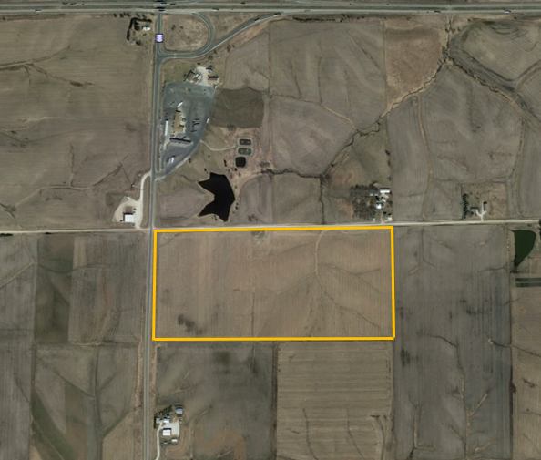
77 acres m/l

Price & Terms
$646,800 total, $8,400 per acre on 77 acres. 10% down upon acceptance of offer, balance due in cash at closing.

Legal Description
Poweshiek County – The North Half of the Northwest Quarter in Section 3, Township 79 North, Range 13 West of the 5th P.M., Poweshiek County, Iowa.

Estimated Net Taxes
Taxes Payable 2018-2019: $2,174
Ne

Net Taxable acres: 73.05

Possession
Open lease for the 2019 crop year. Possession will be granted to buyer at closing.

FSA Data
Cropland: 74.69 acres
Corn Base Acres: 39.91 acres
Soybean Base Acres: 18.4 acres
Corn PLC Yield: 146 bushels per acre
Soybean PLC Yield: 46 bushels per acre
Farm is enrolled in the ARC-County Farm Program

Corn Suitability Rating
CSR2: 72.8 per AgriData
Poweshiek County Assessor: 72.5 CSR2 on 73.05 net acres

Wind Lease
This property has a wind lease with the North English Wind Project, which is currently in the development phase. For additional information regarding the wind lease, contact Matt or Vince.

Directions
Farm is located ½ mile south of Interstate 80 along Highway 21 on the east side of the pavement. Turn east onto 420th Avenue from Highway 21 and the farm is located on the south side of the gravel road.

Aerial

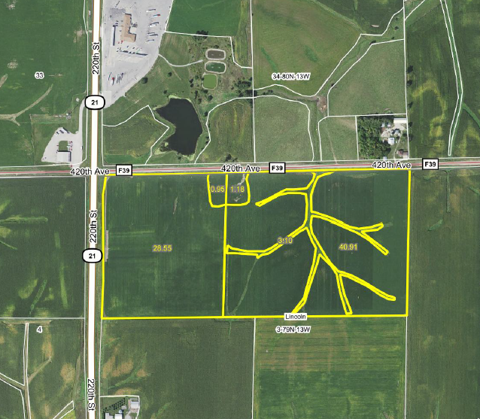
Soils Map

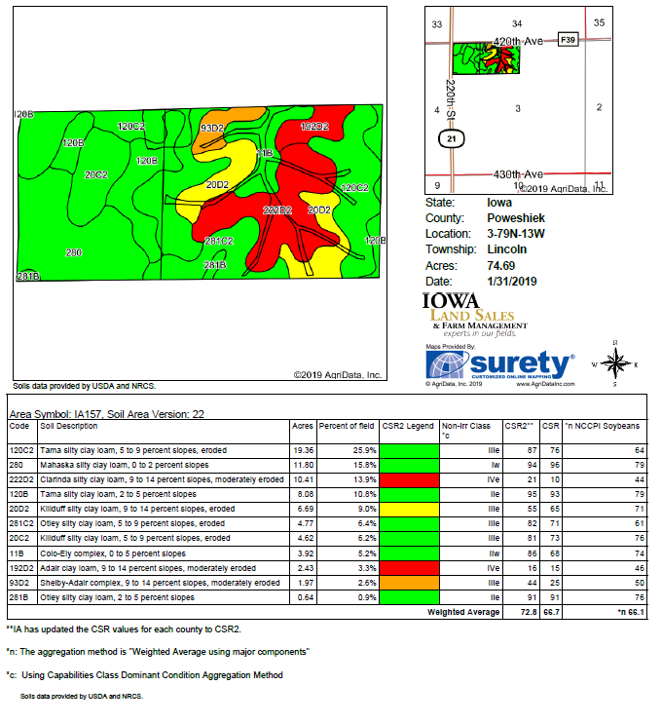

Plat Map

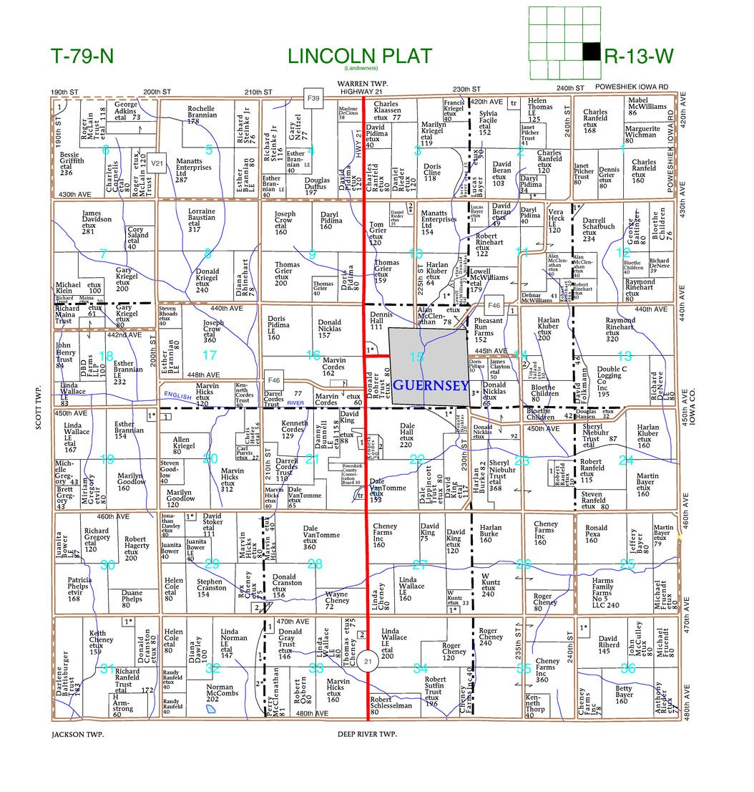

Sale Terms & Announcements

Method: This property is being offered for sale as an individual tract.

Contract & Earnest Payment: A 10% earnest money payment is required upon acceptance of offer and balance will be due at closing.

Closing & Possession: Closing date will be on or about 30 days upon acceptance of offer. Possession will be granted to the buyer at closing.

Announcements: All property is sold on an “As is, Where is” basis. No warranty or guaranty, either expressed or implied, is made by the seller. Sale is subject to all covenants, leases and easements of record. Conducting inspections and due diligence is the responsibility of each party and at their own risk.

Disclaimer: Iowa Land Sales obtained the information above from sources we believe to be reliable. However, we have not verified its accuracy and make no guarantee, warranty or representation about it. It is submitted subject to the possibility of errors, omissions, change of price, rental or other conditions, prior sale, lease or financing, or withdrawal without notice. We include projections, opinions, assumptions or estimates for example only and they may not represent current or future performance of the property. You and your tax and legal advisors should conduct your own investigation of the property and transaction.

